Tourist guide map

AIM : Create html web page for tourists to know about places

* Design a tourist information webpage implementing image hotspot to get useful information about the countries.
* Your webpage should allow the user to select the favourite country from the list box. After selecting, new page should be opened in another tab displaying the country map.
* Implement image hot spot for the country map showing tourist place details for atleast 3 states.
* Make sure all links are opened in new tab.
* You can use additional html tags to make your web page more attractive

HTML TAGS USED IN THIS WEB PAGE :

* <html> - Starting to any html document
* <head> - Heading content of the html file
* <title> - To specify the heading of the page
* <body> - Body content of the html file
* <link> - To link CSS file
* <div> - To create a division like a separate container
* <img> - To link an image into the website
* <select> - To provide user a choice from drop-down
* <option> - To display the available options
* <hx> - heading tag followed by a number noting its size
* <p> - Paragraph tag for text
* <map> - To create hotspot locations on map
* <area> - To specify hotspot area’s

HTML CODE FOR MAIN WEB PAGE :

<!DOCTYPE html>

<html lang="en">

<head>

<meta charset="UTF-8">

<meta http-equiv="X-UA-Compatible" content="IE=edge">

<meta name="viewport" content="width=device-width, initial-scale=1.0">

<title>Tourist Guide</title>

<link rel="stylesheet" href="res/styles.css">

</head>

<body>

<div>

<P>Choose any country:</P>

<select onchange="window.open(this.options[this.selectedIndex].value,'_blank');">

<option></option>

<option value="ind/india.html">India</option>

<option value="mada/madagascar.html">Madagascar</option>

<option value="ny/newyork.html">New York</option>

</select>

</div>

<div id="popup-overlay"></div>

</body>

</html>

CSS CODE FOR Main Site :

body{

background-image: url("b.jpg");

background-repeat: no-repeat;

background-size: 100% ;

}

body div{

position: fixed;

transform: translate(-50%, -50%);

transition: 200ms ease-in-out;

border: none;

border-radius: 20px;

background-color: rgba(255,255,255,1);

box-shadow: 0 15px 30px rgba(0,0,0,.4);

max-width: 80%;

color: black;

align-items: center;

left: 50%;

top: 50%;

width: 400px;

align-items:stretch;

z-index: 97;

}

body div p{

padding-left: 20px;

font-size: 120%;

color: rgba(0,0,0,2);

z-index: 98;

}

body div select{

background-color: rgba(255,255,255,.2);

border: none;

/* border-bottom: 1px solid black; */

outline: none;

cursor: pointer;

z-index: 100;

width: 100%;

padding-left: 9px;

border-bottom-left-radius: 20px;

border-bottom-right-radius: 20px ;

z-index: 99;

}

#popup-overlay{

position: fixed;

top: 0;

left: 0;

right: 0;

bottom: 0;

height: 200%;

padding-left: 9000px;

background: rgba(0,0,0,.4);

pointer-events: none;

}

SCREENSHOTS :



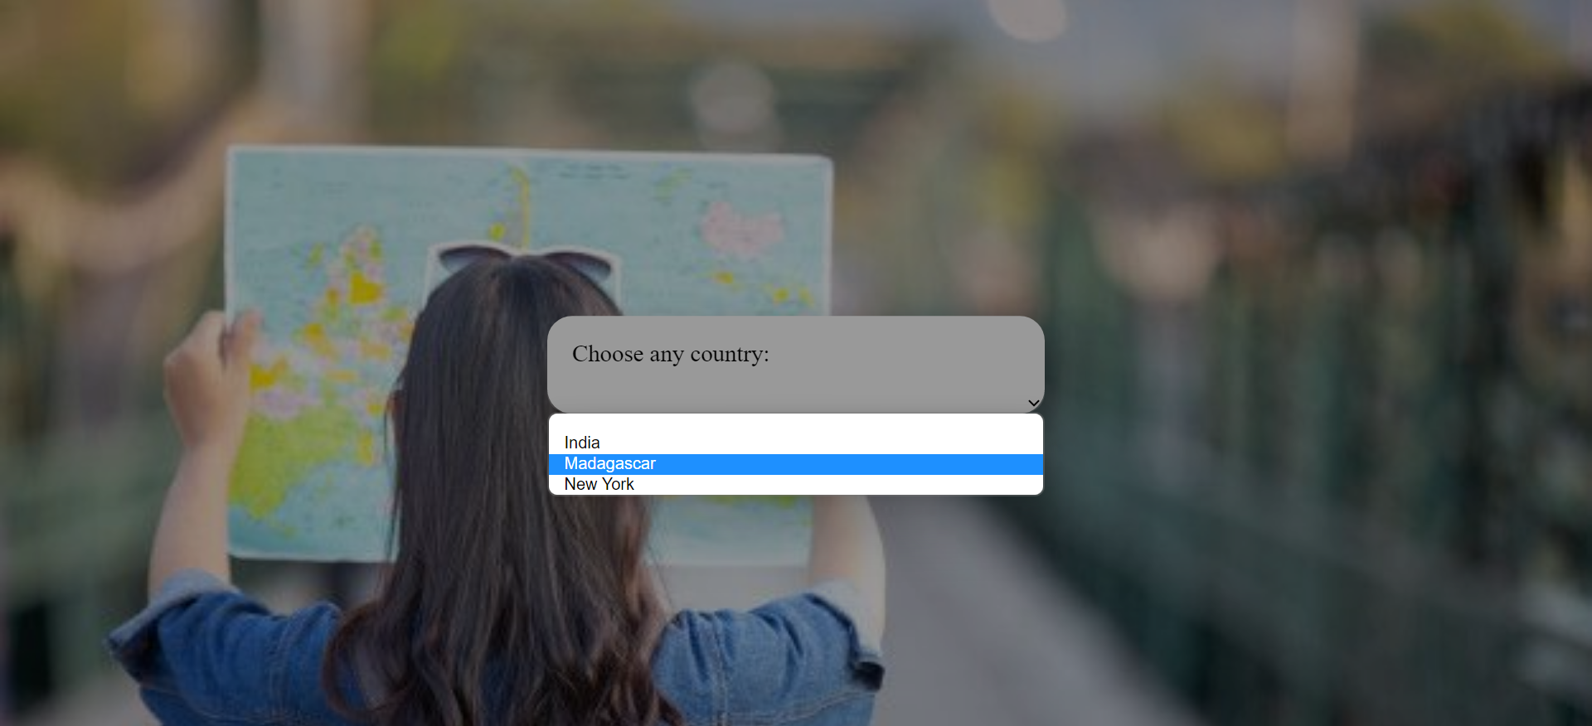

Country PAGE SOURCE:

India:

<!DOCTYPE html>

<html lang="en">

<head>

<meta charset="UTF-8">

<meta http-equiv="X-UA-Compatible" content="IE=edge">

<meta name="viewport" content="width=device-width, initial-scale=1.0">

<title>India</title>

<style>

body{

background-size:cover;

background: linear-gradient(-45deg, #d9a7c7, #eca9d4, #e7e2b4, #fffcdc);

background-size: 400% 400%;

animation: gradient 9s ease infinite;

height: 100vh;

}

@keyframes gradient {

0% {

background-position: 0% 50%;

}

50% {

background-position: 100% 50%;

}

100% {

background-position: 0% 50%;

}

}

</style>

</head>

<body>

<img src = ind.gif alt = "usemap" usemap = "#lessons"/>

<map name = "lessons">

<!-- kerala -->

<area shape="poly" coords="231,915 , 283,954 , 317,1030 , 300,1067 , 248,947" href="kerala.html" alt="" target="_blank">

<!-- Tamil nadu -->

<area shape="poly" coords="416,892 , 403,999 , 316,1077 , 314,952 , 338,922 " href="tn.html" alt="" target="_blank">

<!-- Andhra -->

<area shape="poly" coords="563,682 , 446,794 , 378,897 , 303,836 , 326,809" href="ap.html" alt="">

<!-- karnataka -->

<area shape="poly" coords="324,719 , 296,851 , 350,897 , 288,951 , 209,837 , 227,779 " href="karnataka.html" alt="" target="_blank">

<!-- teangana -->

<area shape="poly" coords="324,719 , 296,851 , 350,897 , 288,951 , 209,837 , 227,779 " href="ts.html" alt="" target="_blank">

</map>

</body>

</html>

Madagascar:

<!DOCTYPE html>

<html lang="en">

<head>

<meta charset="UTF-8">

<meta http-equiv="X-UA-Compatible" content="IE=edge">

<meta name="viewport" content="width=device-width, initial-scale=1.0">

<title>Madagascar</title>

<style>

body{

background-size:cover;

background: linear-gradient(-45deg, #d9a7c7, #eca9d4, #e7e2b4, #fffcdc);

background-size: 400% 400%;

animation: gradient 9s ease infinite;

height: 100vh;

}

@keyframes gradient {

0% {

background-position: 0% 50%;

}

50% {

background-position: 100% 50%;

}

100% {

background-position: 0% 50%;

}

}

</style>

</head>

<body>

<img src = mada.gif alt = "usemap" usemap = "#lessons"/>

<map name = "lessons">

<!-- Fiana -->

<area shape="poly" coords="591,742 , 390,1046 , 326,984 , 238,947 , 300,695" href="Fiana.html" alt="" target="_blank">

<!-- antana -->

<area shape="poly" coords="470,529 , 452,702 , 360,719 , 300,619 , 280,599 , 314,526 " href="ant.html" alt="" target="_blank">

<!-- antsir -->

<area shape="poly" coords="574,36 , 673,311 , 649,366 , 634,308 , 561,219 , 465,183 , 537,152 , 544,76" href="ants.html" alt="" target="_blank">

</map>

</body>

</html>

Newyork:

<!DOCTYPE html>

<html lang="en">

<head>

<meta charset="UTF-8">

<meta http-equiv="X-UA-Compatible" content="IE=edge">

<meta name="viewport" content="width=device-width, initial-scale=1.0">

<title>New York</title>

<style>

body{

background-size:cover;

background: linear-gradient(-45deg, #d9a7c7, #eca9d4, #e7e2b4, #fffcdc);

background-size: 400% 400%;

animation: gradient 9s ease infinite;

height: 100vh;

}

@keyframes gradient {

0% {

background-position: 0% 50%;

}

50% {

background-position: 100% 50%;

}

100% {

background-position: 0% 50%;

}

}

</style>

</head>

<body>

<img src = nyc.gif alt = "usemap" usemap = "#lessons"/>

<map name = "lessons">

<!-- kerala -->

<area shape="poly" coords="812,50 , 809,70 , 812,104 , 746,119 , 733,52" href="clinton.html" alt="" target="_blank">

<!-- Tamil nadu -->

<area shape="poly" coords="729,51 , 714,119 , 718,123 , 721,156 , 669,159 , 655,52 " href="franklin.html" alt="" target="_blank">

<!-- teangana -->

<area shape="poly" coords="634,50 , 654,57 , 668,160 , 601,167 , 510,116 " href="st.html" alt="" target="_blank">

</map>

</body>

</html>

SCREENSHOTS :

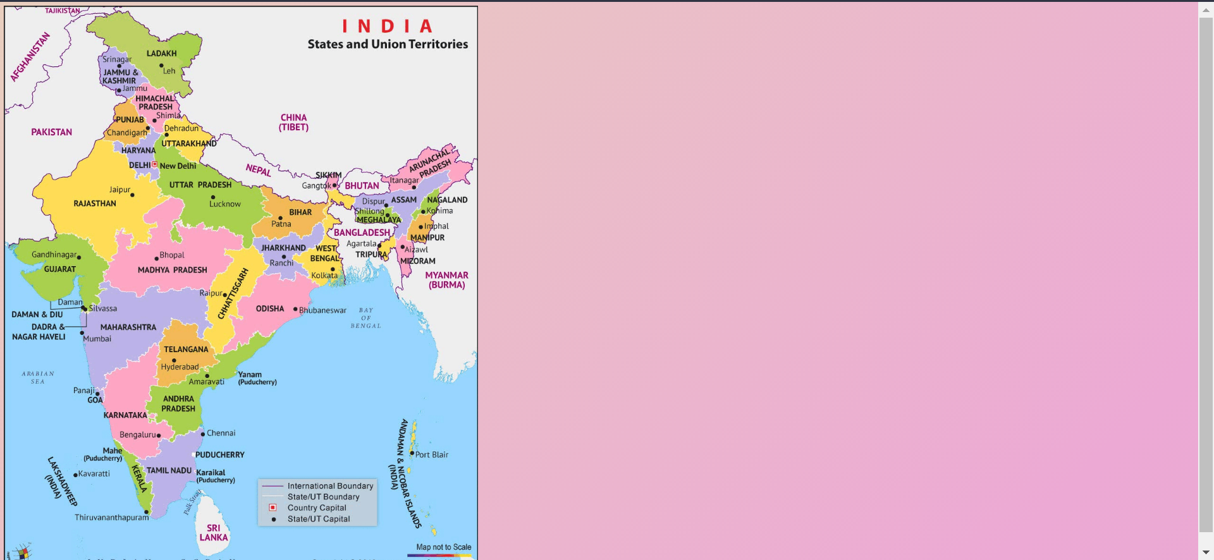

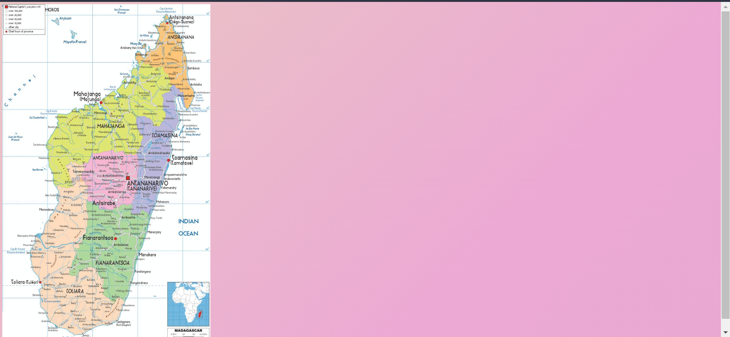

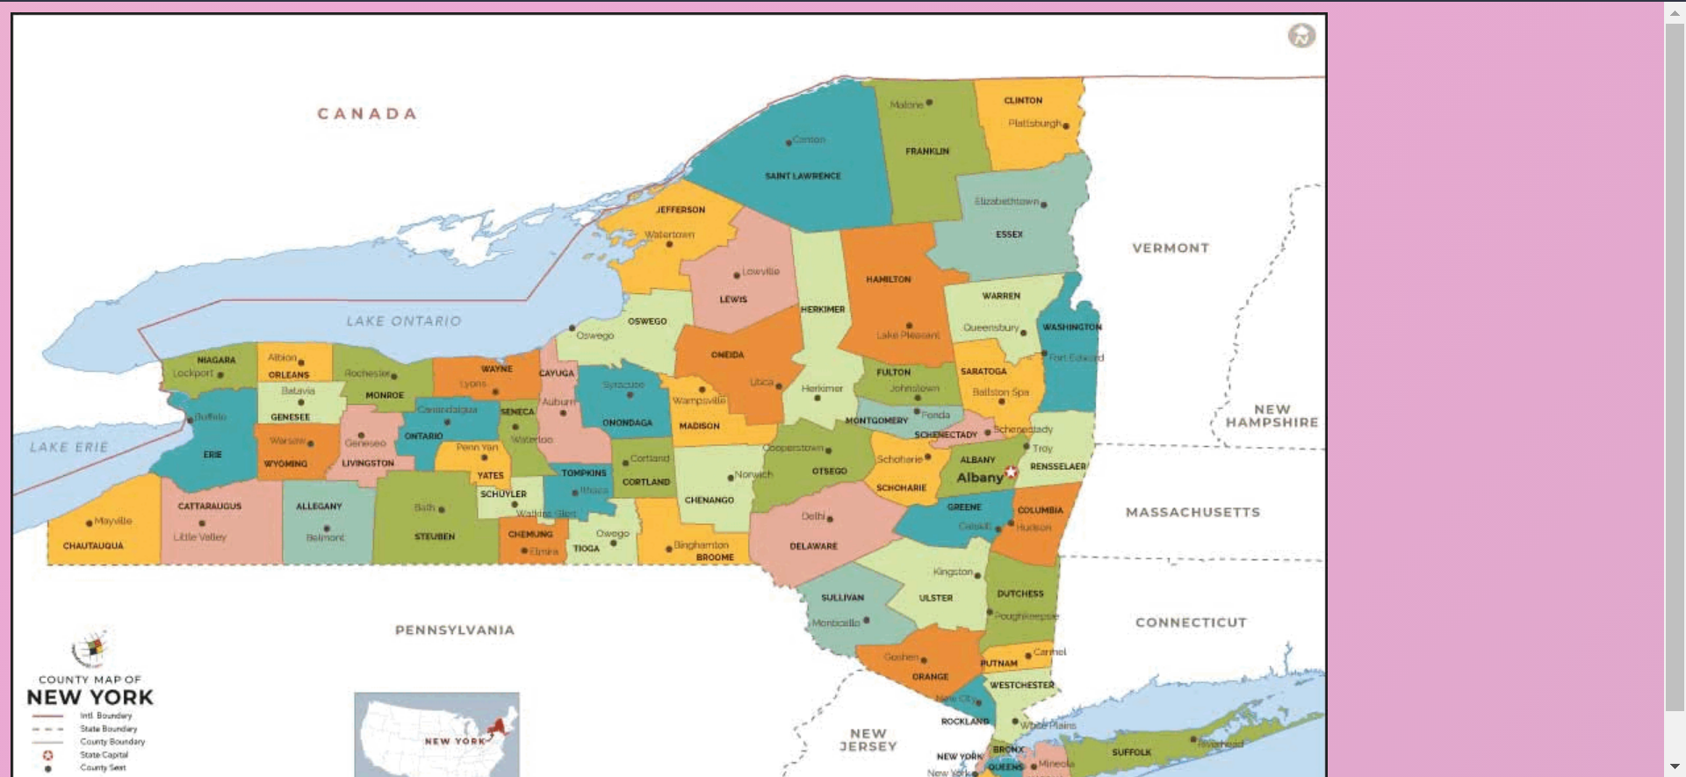

State PAGE SOURCE sample :

Andhra Pradesh:

<!DOCTYPE html>

<html lang="en">

<head>

<meta charset="UTF-8">

<meta http-equiv="X-UA-Compatible" content="IE=edge">

<meta name="viewport" content="width=device-width, initial-scale=1.0">

<title>Andhra pradesh</title>

<link rel="stylesheet" href="../res/states.css">

</head>

<body>

<img src="ap.jpg" alt="" srcset="">

<div class="main">

<h1>Andhra Pradesh</h1>

<hr>

<h2>Tourist spots</h2>

<!-- Portfolio Gallery Grid -->

<div class="row">

<div class="column">

<div class="content">

<h3>KHAJURAHO</h3>

<p>Lorem, ipsum dolor sit amet consectetur adipisicing elit. Nulla accusantium culpa voluptatum non aliquid quidem excepturi modi. Consequuntur sit atque ipsum odit cum, eaque doloremque deserunt commodi at neque quas.</p>

</div>

</div>

<div class="column">

<div class="content">

<h3>PACHAMARHI</h3>

<p>Lorem, ipsum dolor sit amet consectetur adipisicing elit. Impedit reprehenderit voluptas fugit facilis consectetur deleniti, in beatae quis numquam quidem molestias consequuntur quod! Magnam error libero voluptatem corporis. Provident, qui.</p>

</div>

</div>

<div class="column">

<div class="content">

<h3>KANHA-NATIONAL-PARK</h3>

<p>Lorem ipsum dolor, sit amet consectetur adipisicing elit. Temporibus, molestias aperiam. Sunt sint, qui vel dolor recusandae modi ut necessitatibus a, tenetur, nemo ratione dolore fugit optio facilis ea beatae.</p>

</div>

</div>

<div class="column">

<div class="content">

<h3>SANCHI</h3>

<p>Lorem ipsum dolor, sit amet consectetur adipisicing elit. Minus voluptatem, cupiditate vel nobis voluptatum eveniet odit qui perferendis pariatur quisquam maiores odio. Accusamus minus et natus a nisi, repudiandae qui!</p>

</div>

</div>

</div>

<div class="content">

<h3>UJJAIN</h3>

<p>Lorem ipsum dolor sit, amet consectetur adipisicing elit. Expedita quia cum, repellat debitis in modi quasi ullam perferendis sapiente, at vero, accusantium sit excepturi? Ipsa saepe, asperiores porro non dignissimos sequi, architecto doloremque quis, molestiae perferendis harum accusantium ullam fugit molestias deleniti iste ad eos repudiandae quo quia. Numquam, in.</p>

</div>

</div>

</body>

</html>

State PAGE CSS:

* {

box-sizing: border-box;

}

body {

background-color: #f1f1f1;

padding: 20px;

font-family: Arial;

}

.main {

max-width: 1000px;

margin: auto;

}

h1 {

font-size: 50px;

word-break: break-all;

}

.row {

margin: 8px -16px;

}

.row,

.row > .column {

padding: 8px;

}

.column {

float: left;

width: 25%;

}

.row:after {

content: "";

display: table;

clear: both;

}

.content {

background-color: white;

padding: 10px;

}

@media screen and (max-width: 900px) {

.column {

width: 50%;

}

}

@media screen and (max-width: 600px) {

.column {

width: 100%;

}

}

body {

background: linear-gradient(-45deg, #CAC531, #F3F9A7, #adbe0e80, #c9d523);

background-size: 400% 400%;

animation: gradient 9s ease infinite;

height: 100vh;

}

@keyframes gradient {

0% {

background-position: 0% 50%;

}

50% {

background-position: 100% 50%;

}

100% {

background-position: 0% 50%;

}

}

SCREENSHOTS :

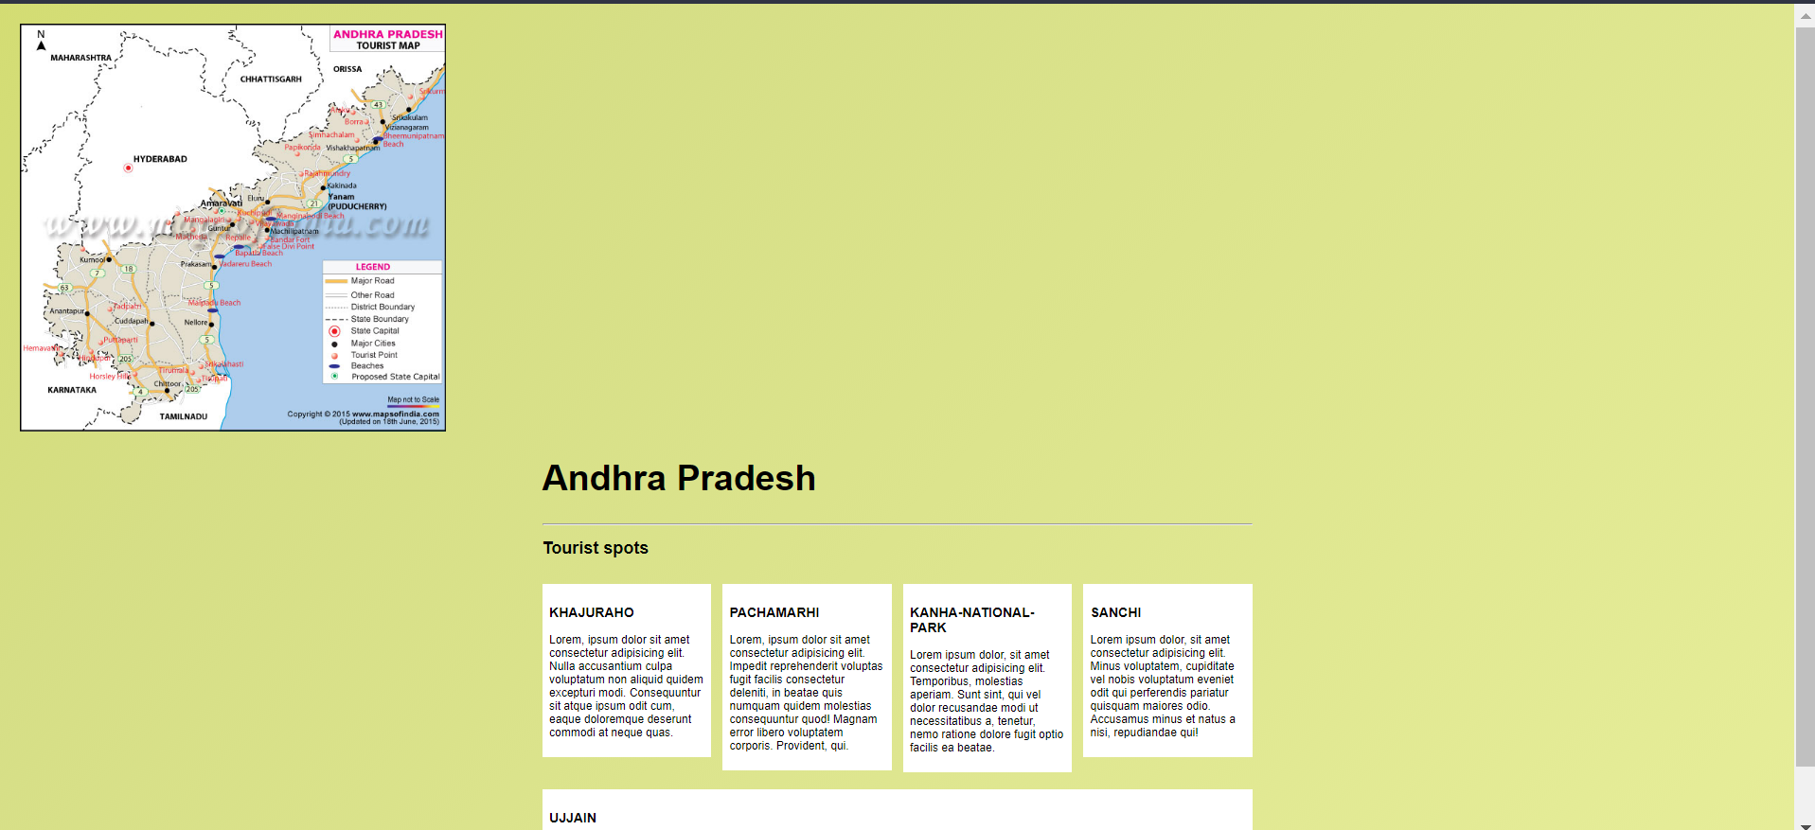

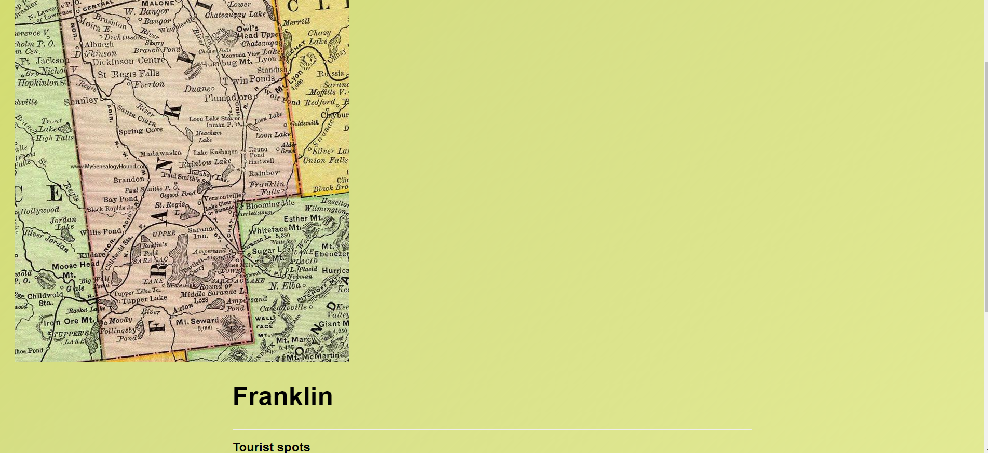

CONCLUSION :

1) We have successfully created a webpage for tourists to explore tourists spots

2) By using various html tags which redirected to create

this webpage.

3) Also created Separate country map pages along with separate state maps detailing the tourist spots available.